MULTIPLE CHOICE 10 marks

- What determines the type of element that an atom will be?

  - Its electric charge
  - Its electron configuration
  - Its number of neutrons
  - Its number of protons

- A particular atom is represented with the following atomic symbol: ${}_{7}^{15}X$

Which of the following is the correct electron configuration for Element X?

  - 2, 5
  - 2, 6
  - 2, 7
  - 2, 8, 5

- Element M is a metallic element which forms positive ions. The formula of a chloride salt of Element M is MCℓ₂. What is the formula of a sulfate salt of M?

  - MSO₄
  - M₂SO₄
  - M(SO₄)₂
  - M₂(SO₄)₃

- Element A has an electron configuration of 1s² 2s² and Element B has an electron configuration of 1s² 2s² 2p⁵. What will be the most likely formula of the compound formed between these two elements?

  - AB
  - AB₂
  - A₂B
  - AB₃

- Which of the following arranges elements in order of increasing ionisation energy?

  - F < Mg < Si < S
  - F < S < Si < Mg
  - Mg < S < Si < F
  - Mg < Si < S < F

- Which of the following statements gives the meaning of ‘electronegativity’?

  - The ability of an atom to accept an electron to form a negatively charged ion
  - The ability of an atom to attract electrons and form bonds with electrons
  - The energy required to remove an electron from the atom in the gas phase
  - The energy released when an electron is added to the atom in the gas phase

- A polar covalent bond is a bond formed when two atoms with different electronegativities share a pair of electrons. The larger the difference in electronegativity, the greater the polarity of the bond.

Which combination of atoms would form the most polar bond?

  - Two fluorine atoms bonded together
  - A fluorine atom and an iodine atom
  - A fluorine atom and a bromine atom
  - A fluorine atom and a chlorine atom

- The following diagram shows emission spectra for four elements and an unknown sample.

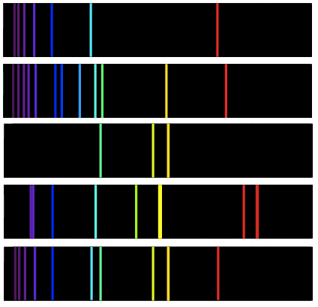
Helium:
Hydrogen:
Sodium:
Mercury:
Unknown:

Which option in the table below correctly identifies whether or not hydrogen, helium, sodium and mercury are present in the unknown sample?

 | Hydrogen | Helium | Sodium | Mercury
(a) | x | ✔ | x | x
(b) | ✔ | x | ✔ | x
(c) | x | ✔ | ✔ | x
(d) | ✔ | ✔ | ✔ | x

- Which of the following best describes the composition and properties of a pure substance?
 | Composition | Physical and chemical properties
(a) | Homogeneous | Constant
(b) | Homogeneous | Variable
(c) | Heterogeneous | Constant
(d) | Heterogeneous | Variable

- A mixture of methanol and water can be separated by simple distillation (diagram of apparatus shown below). Methanol has a boiling point of 67 °C and water has a boiling point of 100 °C.

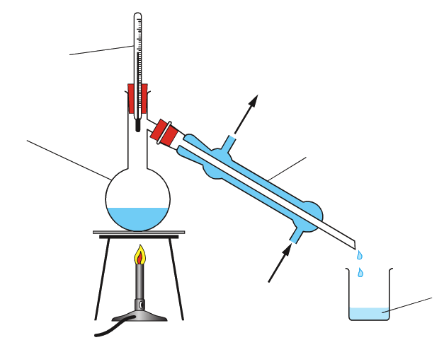
Thermometer
Condenser
Beaker
Round-bottom flask
Cool water in
Cool water out

Which of the following correctly describes the distillate in this procedure?

  - The distillate is pure water, and it is collected in the beaker
  - The distillate is pure water, and it remains in the round-bottom flask
  - The distillate is pure methanol, and it is collected in the beaker
  - The distillate is pure methanol, and it remains in the round-bottom flask

SHORT ANSWER 45 marks
- (4 marks)

- Write the formulas of the following compounds:

Answer | Marks
- NaMnO₄ | 1 mark
- Zn(OH)₂ | 1 mark
Total marks: | 2 marks

- Write the names of the following compounds:

Answer | Marks
- Sulfur difluoride | 1 mark
- Copper(II) iodide | 1 mark
Total marks: | 2 marks

- (5 marks)

Submarines and spacecraft generate oxygen by the decomposition of potassium chlorate, KCℓO₃. This decomposition reaction is shown below:

2 KCℓO₃ (s) 2 KCℓ (s) + 3 O₂ (g)

- What does the formula KCℓO₃ indicate about the relative numbers of atoms in the compound?
(1 mark)

Answer | Marks
For every 1 potassium atom there is 1 chlorine atom and 3 oxygen atoms | 1 mark
Total marks: | 1 mark

- What mass of oxygen gas would be produced from the decomposition of 138.6 g of KCℓO₃. Show all working and give your final answer to three significant figures. (4 marks)

Answer | Marks
Calculates M(O₂) = 16.00 g mol⁻¹ and M(KClO₃) = 122.55 g mol⁻¹ | 1 mark
n(KClO₃) = m / M = 138.6 / 122.55 = 1.13 mol | 1 mark
n(O₂) = 3/2 x n(KClO3) = 1.70 mol | 1 mark
m(O₂) = n x M = 1.70 x 32 = 54.286 = 54.3 g | 1 mark
Deduct 0.5 marks if missing or incorrect units  Deduct 0.5 marks if answer is not to 3 significant figures | -
Total marks: | 4 marks

- (6 marks)

- Compare and contrast the charge and relative mass of protons and neutrons. (2 marks)

Answer | Marks
Both have the same relative atomic mass | 1 mark
Protons and positive and neutrons and neutral | 1 mark
Total marks: | 2 marks

- Within the nucleus there are both attractive forces and repulsive forces. In the table below:
- Give the names of the attractive and repulsive forces in the nucleus
- Draw arrows on the diagram to show which particles the forces are acting between.

 | Attractive force | Repulsive force
Name of force | Strong nuclear force | Electrostatic repulsion
Diagram representation | p  n  n  p | 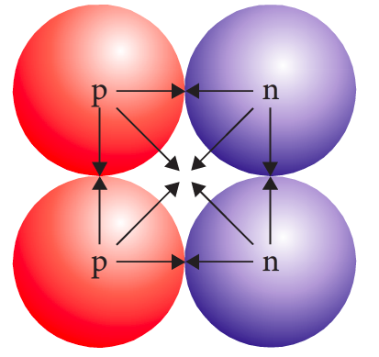

Answer | Marks
Names | 2 x 1 mark
Diagrams (must show directions and all involved particles) | 2 x 1 mark
Total marks: | 4 marks

- (2 marks)

- What does the value of an atom’s relative atomic mass (A_{r}) indicate? (1 mark)

Answer | Marks
Its mass relative to 1/12th of a carbon-12 atom | 1 mark
Total marks: | 1 mark

- Tin has a relative atomic mass of 118.7 according to the periodic table, but no single atom of tin has a relative atomic mass of 118.7. Account for this difference. (1 mark)

Answer | Marks
The number 118.7 is an average mass of different isotopes of tin | 1 mark
Total marks: | 1 mark

- (2 marks)

Complete the following table:

Symbol (${}_{\text{Z}}^{\text{A}}{\text{X}}$) | Atomic number | Mass number | Number of protons | Number of neutrons
$${}_{\text{42}}^{\text{95}}{\text{Mo}}$$ | 42 | 95 | 42 | 53
$${}_{\text{47}}^{\text{109}}{\text{Ag}}$$ | 47 | 109 | 47 | 62

Answer | Marks
All correct as per table above | 2 marks
Deduct 0.5 marks per incorrect / blank box | -
Total marks: | 2 marks

- (5 marks)

- Give the common names for elements in Group 17 and Group 18 on the Periodic Table. (1 mark)

Answer | Marks
Group 17: Halogens | 1 mark
Group 18: Noble gases / Inert gases | 1 mark
Total marks: | 2 marks

- What criteria is used to sort elements on the periodic table from left to right? (1 mark)

Answer | Marks
Increasing atomic number OR increasing number of protons | 1 mark
Total marks: | 1 mark

- Elements in the same group of the periodic table share the same number of valence electrons, but the current layout of the periodic table was constructed prior to our understanding of electron configurations and valence electrons.
What criteria was used to arrange elements into groups before the existence of valence electrons was known? Give an example to support your answer. (2 marks)

Answer | Marks
Was based on properties of elements | 1 mark
Gives example of a group with similar chemical properties. Examples:  ‘All elements in Group 18 are non-reactive gases’  ‘All Group 1 metals are reactive and explode in contact with water’ | 1 mark
Total marks: | 1 mark

- (4 marks)

The periodic table shows trends in ionisation energy, electronegativity, electron affinity and atomic radius.

- Define ionisation energy. (1 mark)

Answer | Marks
Energy required to remove an electron from an atom | 1 mark
Total marks: | 1 mark

- State and explain the trend in atomic radius as you go across Period 2. (3 marks)

Answer | Marks
Increases | 1 mark
There is a greater number of protons in nucleus… | 1 mark
…resulting in greater strength of attraction between nucleus and electrons | 1 mark
Total marks: | 3 marks

- (4 marks)

Electron configurations can be represented using either the shell model (e.g. Hydrogen has a shell configuration of 1) or the sub-shell model (e.g. Hydrogen has a sub-shell configuration of 1s¹).

Complete the table to show the electron configurations of nitrogen and potassium using each method.

Element | Electron configuration
 | Shell model | Sub-shell model
Nitrogen | 2, 5 | 1s² 2s² 2p³
Potassium | 2, 8, 8, 1 | 1s² 2s² 2p⁶ 3s² 3p⁶ 4s¹

Answer | Marks
As per table above | 4 x 1 mark
Total marks: | 4 marks

- (5 marks)
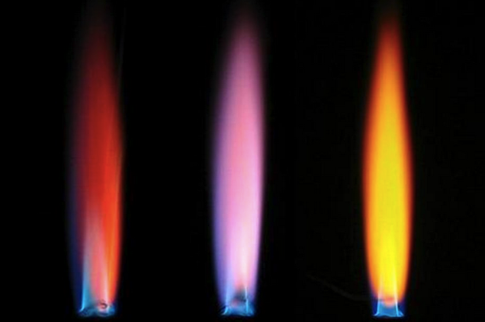
A flame test is a practical test which involves heating a metal salt directly on a flame. The salts give off different coloured light resulting in different coloured flames. This is the same principle behind the operation of fireworks, which contain similar types of metal salts.
The photograph to the right demonstrates this process. The three salts in the flames are (left to right):
Calcium chloride, potassium nitrate, sodium chloride.

- Write the chemical formulas for calcium chloride and potassium nitrate. (1 mark)

Answer | Marks
Calcium chloride: CaCl₂  Potassium nitrate: KNO₃ | 2 x 0.5 marks
Total marks: | 1 mark

- Explain why metal salts give off certain colours of light when heated by the flame. (2 marks)

Answer | Marks
Heat excites electron to an excited state | 1 mark
Electron releases light when it relaxes to the ground state | 1 mark
Award 1 mark / 2 for answers which describe process in general terms but do not use specific terminology such as ‘excite’ and ‘ground state’ | -
Total marks: | 2 marks

- Explain why the flame colour for sodium chloride is different to the flame colour for calcium chloride.
(2 marks)
Answer | Marks
Sodium has a different electron configuration to calcium | 1 mark
There are different amounts of energies between orbitals, hence different wavelengths of light are emitted | 1 mark
Total marks: | 2 marks

- (3 marks)

- Classify the following substances by listing them in the correct columns in the table below.

Pure substance |  | Mixture
Element | Compound | Homogeneous | Heterogeneous
Iodine  P₄ (s)  ………………….... | CaO (s)  …………………....  ………………….... | NaCl (aq)  Vinegar  ………………….... | Blood  …………………....  …………………....

Answer | Marks
As per table above | 6 x 0.5 marks
Total marks: | 3 marks

- (5 marks)

Kerosene and ethanol are two immiscible liquids. The properties of these liquids are described below.

 | Ethanol | Kerosene
Boiling point | 78 °C | 150 °C
Density | 789 kg/m³ | 810 kg/m³
Colour | Colourless | Colourless
Reactivity | Flammable | Flammable

- List a separating technique that will separate these substances based on boiling point. (1 mark)

Answer | Marks
Distillation | 1 mark
Total marks: | 1 mark

- List a separating technique that will separate these substances based on density and solubility.
(1 mark)
Answer | Marks
Separating funnel | 1 mark
Total marks: | 1 mark

- If you were required to separate these substances in class, which of the above methods would you use? Justify your answer by listing three advantages of your chosen method. (3 marks)

Answer | Marks
Reasons for picking separating funnel:  - Both liquids are flammable (should avoid methods that involve open flames)  - Separating funnel is faster to set up / use  - Does not require running water to be available  - Does not require gas to be available  - Glassware is cheaper / more readily available | 3 x 1 mark
Total marks: | 3 marks

